Hands on #2 – Spark with Hadoop + Azure Blob cluster

This is the continuation workshop after deploying Hadoop + Azure Blob cluster;

1. Download apache Spark stable release - <https://spark.apache.org/downloads.html>

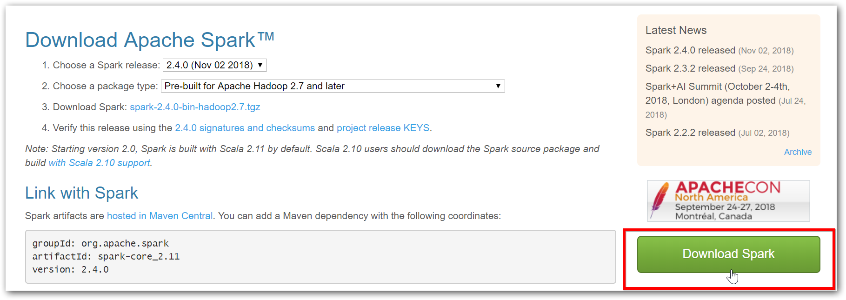

1. Set SPARK_HOME as environment variables (without bin),

|  |  |
| --- | --- |
| SPARK_HOME | D:\Spark\spark-2.4.0-bin-hadoop2.7\spark-2.4.0-bin-hadoop2.7\ |

1. Create a file called **spark-env.cmd** in directory “D:\Spark\spark-2.4.0-bin-hadoop2.7\spark-2.4.0-bin-hadoop2.7\conf\” and paste the following content in it,

|  |
| --- |
| @echo off  if exist %HADOOP_HOME%\etc\hadoop (  set HADOOP_CONF_DIR=%HADOOP_HOME%\etc\hadoop  )    if not defined SPARK_CONF_DIR (  set SPARK_CONF_DIR=%SPARK_HOME%\conf  )  SET PATH=%PATH%;%JAVA_HOME%\bin;%HADOOP_HOME%\bin;  SET SPARK_SUBMIT_CLASSPATH=%SPARK_HOME%\jars\derby\*  set SPARK_LOCAL_HOSTNAME=%COMPUTERNAME%  SET SPARK_DIST_CLASSPATH=%SPARK_HOME%\jars\*;%HADOOP_HOME%\share\hadoop\client\*;%HADOOP_HOME%\share\hadoop\common\*;%HADOOP_HOME%\share\hadoop\common\lib\*;%HADOOP_HOME%\share\hadoop\hdfs\*;%HADOOP_HOME%\share\hadoop\hdfs\lib\*;%HADOOP_HOME%\share\hadoop\mapreduce\*;%HADOOP_HOME%\share\hadoop\mapreduce\lib\*;%HADOOP_HOME%\share\hadoop\tools\lib\*;%HADOOP_HOME%\share\hadoop\tools\sources\*;%HADOOP_HOME%\share\hadoop\yarn\*;%HADOOP_HOME%\share\hadoop\yarn\lib\* |

1. Download and copy the following jars to “D:\Spark\spark-2.4.0-bin-hadoop2.7\spark-2.4.0-bin-hadoop2.7\jars”
   1. azure-storage-8.0.0.jar ([link](http://central.maven.org/maven2/com/microsoft/azure/azure-storage/8.0.0/azure-storage-8.0.0.jar))
   2. hadoop-azure-2.7.7.jar ([link](http://central.maven.org/maven2/org/apache/hadoop/hadoop-azure/2.7.7/hadoop-azure-2.7.7.jar))
2. Open “spark-shell.cmd” and observe the output (perhaps with few WARN messages that you can simply disregard).

../spark-2.4.0-bin-hadoop2.7/bin> spark-shell.cmd

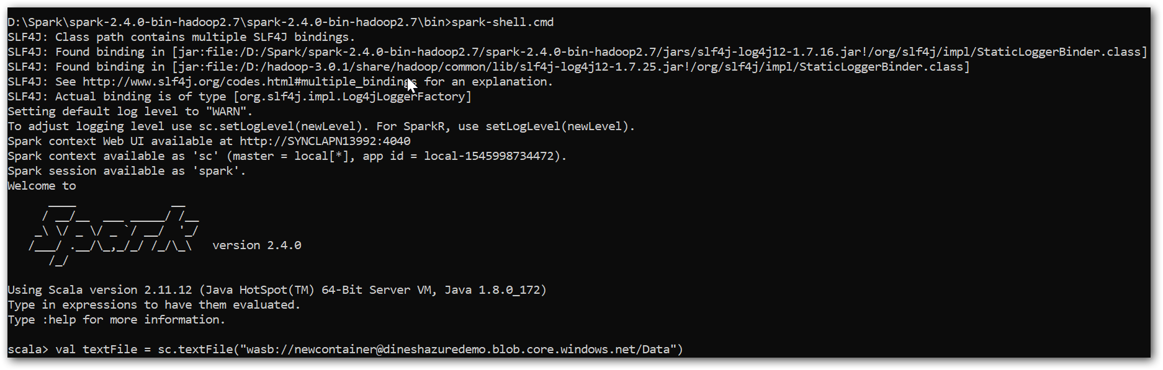

1. Tryout your first Spark-Scala code over file present in Azure Blob to find the number of lines,

scala> sc.textFile("wasb://newcontainer@dineshazuredemo.blob.core.windows.net/Data/word-count-data.txt").count()



1. And now perform wordcount over file present in Azure Blob and store the data into HDFS,

|  |
| --- |
| scala> val textFile = sc.textFile("wasb://newcontainer@dineshazuredemo.blob.core.windows.net/Data/word-count-data.txt")  scala> val counts = textFile.flatMap(line => line.split(" ")).map(word => (word, 1)).reduceByKey(_+_)  scala> counts.saveAsTextFile("/SparkOutput") |

You can find more samples at <https://spark.apache.org/examples.html>

1. Now let’s start to do samples with NASA logs,
   1. scala> :load "D:\Workshop\Scala Scripts\Scala Scripts\Exercise_1.scala"